***Science Advances***

**Manuscript Template**

**General Instructions on using this template and submitting a new manuscript to *Science Advances***

Use this template to speed the processing of your paper.

We need to accurately record

the title, authors, abstract, and other component parts of your paper so we can enrich it with reference links and an accurate layout.

Please use the actual template starting on the next page, which

includes more specific formatting instructions.

You can submit your paper at <https://cts.sciencemag.org>

Additional instructions are available at <https://advances.sciencemag.org/content/information-authors>

**When you are ready to submit, please delete this box with all its contents.**

**Your manuscript should start on Page 1.**

**Front Matter**

Title

Microplastics are present in cow follicular fluid and can compromise gamete function *in vitro*: Is the Anthropocene throw-away society throwing away fertility?

* Short title can be a maximum of 50 characters.

Microplastics impair gametes function *in vitro*

**Authors**

Nicole Grechi Ribeiro1, Roksan Franko1,2, Roshini Rajamaran2, Jan Stöckl1, Thomas Frölich1, Michael J. Noonan3, Marcia de A. M. M. Ferraz1,2*

1Clinic of Ruminants, Faculty of Veterinary Medicine, Ludwig-Maximilians University of Munich, Sonnenstr. 16, Oberschleissheim, 85764, Germany

2Gene Center, Ludwig-Maximilians University of Munich, Feodor-Lynen Str. 25, Munich, 81377, Germany

3The Irving K. Barber School of Sciences, The University of British Columbia, Okanagan Campus, Kelowna, BC V1V 1V7, Canada

*Corresponding author: E-mail: m.ferraz@lmu.de

**Abstract**

The abstract should be a single paragraph (**no more than 150 words**) written in plain language that a general reader can understand. Do not include citations. The abstract should provide:

* An opening sentence that states the question/problem addressed by the research
* Enough background content to give context to the study
* A brief statement of primary results
* A short concluding sentence

**Teaser**

This one-sentence summary (125 characters with period) provides a snapshot of your research for non-specialist readers and should complement rather than repeat the title.

**MAIN TEXT**

**The manuscript should be a maximum of 15,000 words.**

**Introduction**

Decades of careless use and improper disposal have resulted in plastic pollution accumulating almost everywhere on earth (*1*, *2*) and microplastics – defined as plastic particles <5 mm in size that are insoluble in water – have now been documented in even the most remote environments (*3*–*5*). The exponentially increasing volume of plastic pollution making its way into rivers, lakes and oceans has drawn considerable scientific, public, and governmental attention (*6*). However, despite the tens of thousands of peer reviewed publications on plastic pollution, the overwhelming majority of these have focused on aquatic ecosystems, and very little is known about the effects of MPs in terrestrial systems (*7*). This knowledge gap is made all the more noteworthy by the fact that 80% of the Earth’s species live on land (*8*) and terrestrial systems may represent a larger environmental reservoir of MPs than oceans (*9*, *10*). With the plastic pollution crisis only expected to worsen over the coming decades (*11*), it is imperative that we improve our understanding of the potential health effects of the tens of billions of tons of plastic pollution that litter the globe.

While any health effects are undesirable, the potential impacts of MPs on reproductive systems are of particular concern. Reproduction is central to the capacity for species to maintain stable populations. Poor reproductive health not only reduces individual fecundity but, if widespread, species survival. Over the past several decades there has been an alarming increase in the rates of reproductive dysfunctions and gamete abnormalities, reductions in gamete production, and altered embryo development in humans, animals and plants (*15*–*23*). While the overarching cause of these declines in fertility has yet to be identified, emerging studies are showing that MPs represent a potentially serious threat to the reproductive health of terrestrial species (*10*, *24*–*26*). Data have been limited to studies on laboratory animals, however, and the extent to which they are representative of the conditions animals are actually experiencing in the real world is unknown. For example, Jin et al. (*24*) studied the effects of MPs on fertility by feeding mice MPs at concentrations that were ca. 100,000 times greater than they would be exposed to in the wild (*27*). This means that it is unclear to what extent MPs can bio-accumulate in free-ranging terrestrial mammals and influence fertility. Here, we assessed the extent to which MPs might be bioaccumulating in the follicular fluid of domestic cows. Particles isolated from bovine follicular fluid were identified via Raman spectroscopy, and the composition of particles were compared to water controls. We then investigated the effects of MPs on bovine male and female gametes *in vitro* at biologically realistic concentrations. already

**Results**

**MPs, pigments, and plasticizers in cow follicular fluid**

A high number of undigested matter was detected in the bovine follicular fluid (FF) samples. Automated analysis of the sample membranes, using the software Partcile Scout, identified a total of 12,309 particles in FF1, 40,154 in FF2, 40,683 in FF3, 9,049 in water 1 and 4,912 in water 2 (Fig. 1A). Despite the large number of particles, only 331, 507, 4392, 367 and XX particles for FF1, FF2, FF3, water 1 and water 2, respectively, had Raman spectra with HQI ≥ 75. Figure 1B shows examples of plastic polymers identified in FF and their spectra match. MPs were found in all FF samples, with a mean concentration of 132.3 particles mL-1 (Fig. 1C; Table S1). The number of MP particles varied substantially between samples, with a total of 17 particles mL-1 in FF1, 21 particles mL-1 in FF2 and 359 particles mL-1 in FF3. ~~The number of particles was adjusted to the particles detected in the water control by subtracting the number of particles detected in the water controls from the number of particle in FF, for each specific polymer detected individually.~~ Non-plastic related particles were the majority of identified particles (56 to 74 %), while MP polymers accounted for 9.4 to 19.9 % of total identified particles. Other plastic-related particles that were identified included pigments (0.3 to 2.5 %), plasticizers (1.6 to 18.0 %), and coating, solubilizers and fillers (5.9 to 12.2 %; Fig. 1D). A total of 24 different MP polymers were identified, with the most abundant being cotton, followed by cellulose, polyvinyl chloride, polyethylene, polystyrene, polypropylene and silicon, respectively. The sizes of the MPs in bovine follicular fluid ranged from 3.2 to 56.9 μm in length (mean±SD = 9.8±4.5 μm) and 1.6 to 23.6 μm in width (mean±SD = 5.8±2.9 μm). Based on their sizes and densities, we determined that MPs summed to 0.002 μg mL-1 in FF1, 0.005 μg mL-1 in FF2 and 0.172 μg mL-1 in FF3. Of importance for the present study, polystyrene in FF3 equalled to 0.0126 μg mL-1 and to 0.00035 μg mL-1 in FF2, while it was not identified in FF1. Full details on the MP particles contained in each of the samples are shown in Data S2.

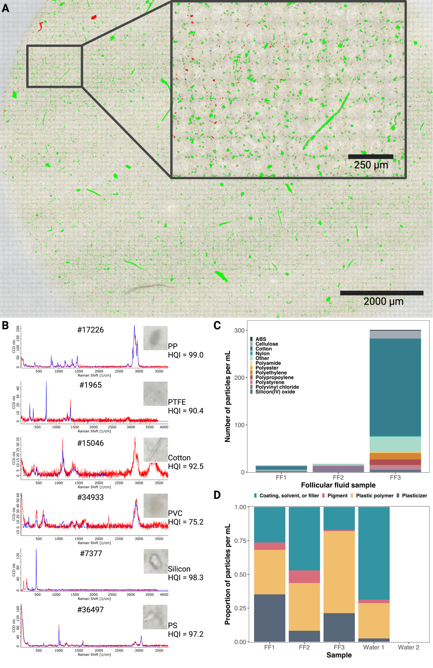

**Fig. 1.** **MPs were detected in bovine follicular fluid.** In (**A**), an example of an imaged membrane that was used in the software Particle Scout to determined the number of particles and their sizes and for subsequent spectra match using the software TrueMatch is shown. Green particles represent counted particles and red particles represent counted particles for which the spectra match had an HQI ≥ 75. In (**B**) examples of plastic polymer particles from FF3 with their Raman spectra (red) and the matched Raman spectra of the corresponding plastic polymer (blue) from the ST Japan and/or MICROPLASTIC database. Particle number, polymer name and HQI are shown. In (**C**) the counts of the different plastic and non-plastic analysed particles present in each sample are shown. In (**D**) the composition of MPs detected in follicular fluid by confocal Raman spectroscopy are shown. The number of MPs in (**C**) and (**D**) were adjusted to the number of particles detected in the water control.

**MPs reduce oocyte maturation and induce damage of the zona pellucidae**

In order to evaluate the effects of MPs on *in vitro* oocyte maturation, we counted the number of oocytes with broken zona pellucida, that were degenerating and that were mature (Fig. 2A). The presence of a polar body and a clear chromosome alignment without degradation was considered for oocytes that were mature. The oocytes with broken zona pellicidae were all those that independently of the nuclear stage, had a disruption of the zona pellucidae. For the degenerating oocytes, the shrinking of the cytoplasm, and the absence or degradation of genetic material was considered. Independent of the size, *in vitro* maturation performed in the presence of polystyrene beads resulted in a significantly lower number of mature oocytes in comparison to the control group (control: 68.1±10.3%, 0.3 μm MPs: 42.0±14.8, and 1.1 μm MPs: 41.0±17.6%; p < 0.00001 for both 0.3 and 1.1 μm MPs; Fig. 2A). There was no significant difference in the number of mature oocytes between the 0.3 and 1.1 μm MP treatments (p = 0.963). The number of degenerated oocytes varied between 27% and 37% and did not differ between any of the groups, however the control group had significantly fewer oocytes with broken zona pellucidae when compared to the groups incubated with MP beads (control: 4.4±5.2%, 0.3 μm MPs: 21.4±7.6, and 1.1 μm MPs: 26.2 ±10.9%; p < 0.0001 for all groups). Notably, of the oocytes with broken zona pellucidae 80 were mature in the control group, as compared to 40 and 35%, for the 0.3 and 1.1 μm MP treatments, respectively, but these oocytes were counted as broken zona pellucida, and not as mature.

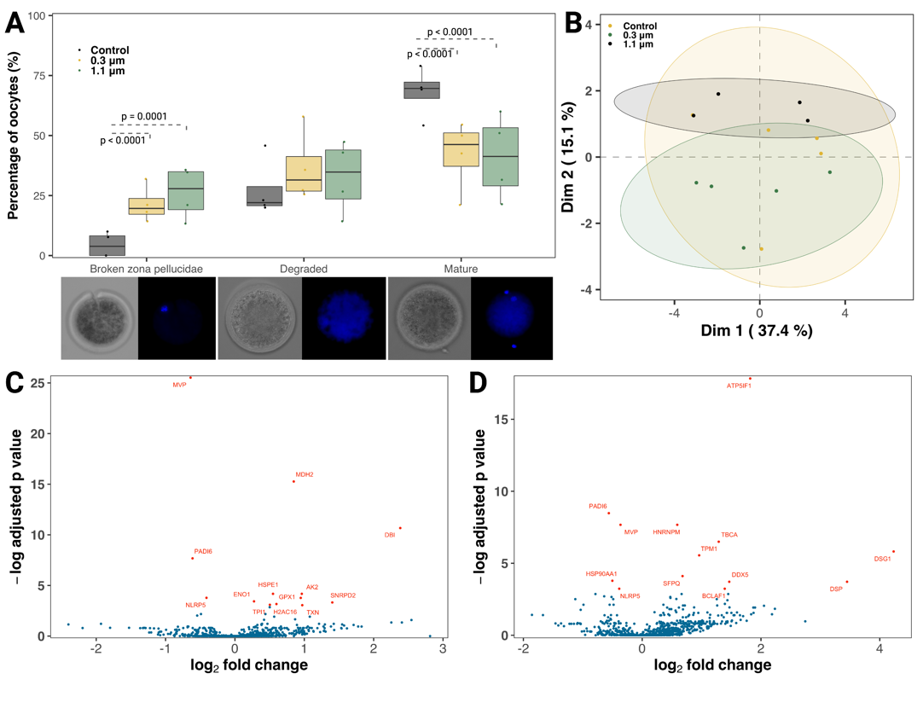

**Fig. 2.** **Polystyrene** **MPs negatively influenced oocyte maturation.** The boxplots in (**A**) show the effects of 24 h exposure to 0.3 and 1.1 μm polystyrene beads on oocyte maturation *in vitro.* Image examples of each stage characterization below the panel. The scatter plot in (**B**) depicts the first two dimensions (Dim) of a principal component analysis (PCA) across the proximity matrix of a random forest model classifying oocytes exposed to 0.3 or 1.1 μm polystyrene beads versus the control, based on protein expression profiles. Volcano plots depicting differently expressed proteins between oocytes incubated for 24 h in the presence of (**C**) 0.3 μm and (**D**) 1.1 μm polystyrene beads compared to a control are also shown.

**Oocytes proteomics**

**MPs attach to the sperm surface but are not internalized**

Due to the physical limitations of the microscope, only the larger 0.3 and 1.1 μm polystyrene beads were analysed for attachment. We observed that sperm incubated in the presence of 0.3 μm polystyrene beads had a higher number of beads attached to the surface than those incubated with the 1.1 μm beads (p < 0.001; Fig. 3A). We also found that the percentage of sperm with attached MP beads did not change over time (p = 0.3). From our microscopy analyses, we found no evidence of polystyrene beads being internalized by the sperm cells.

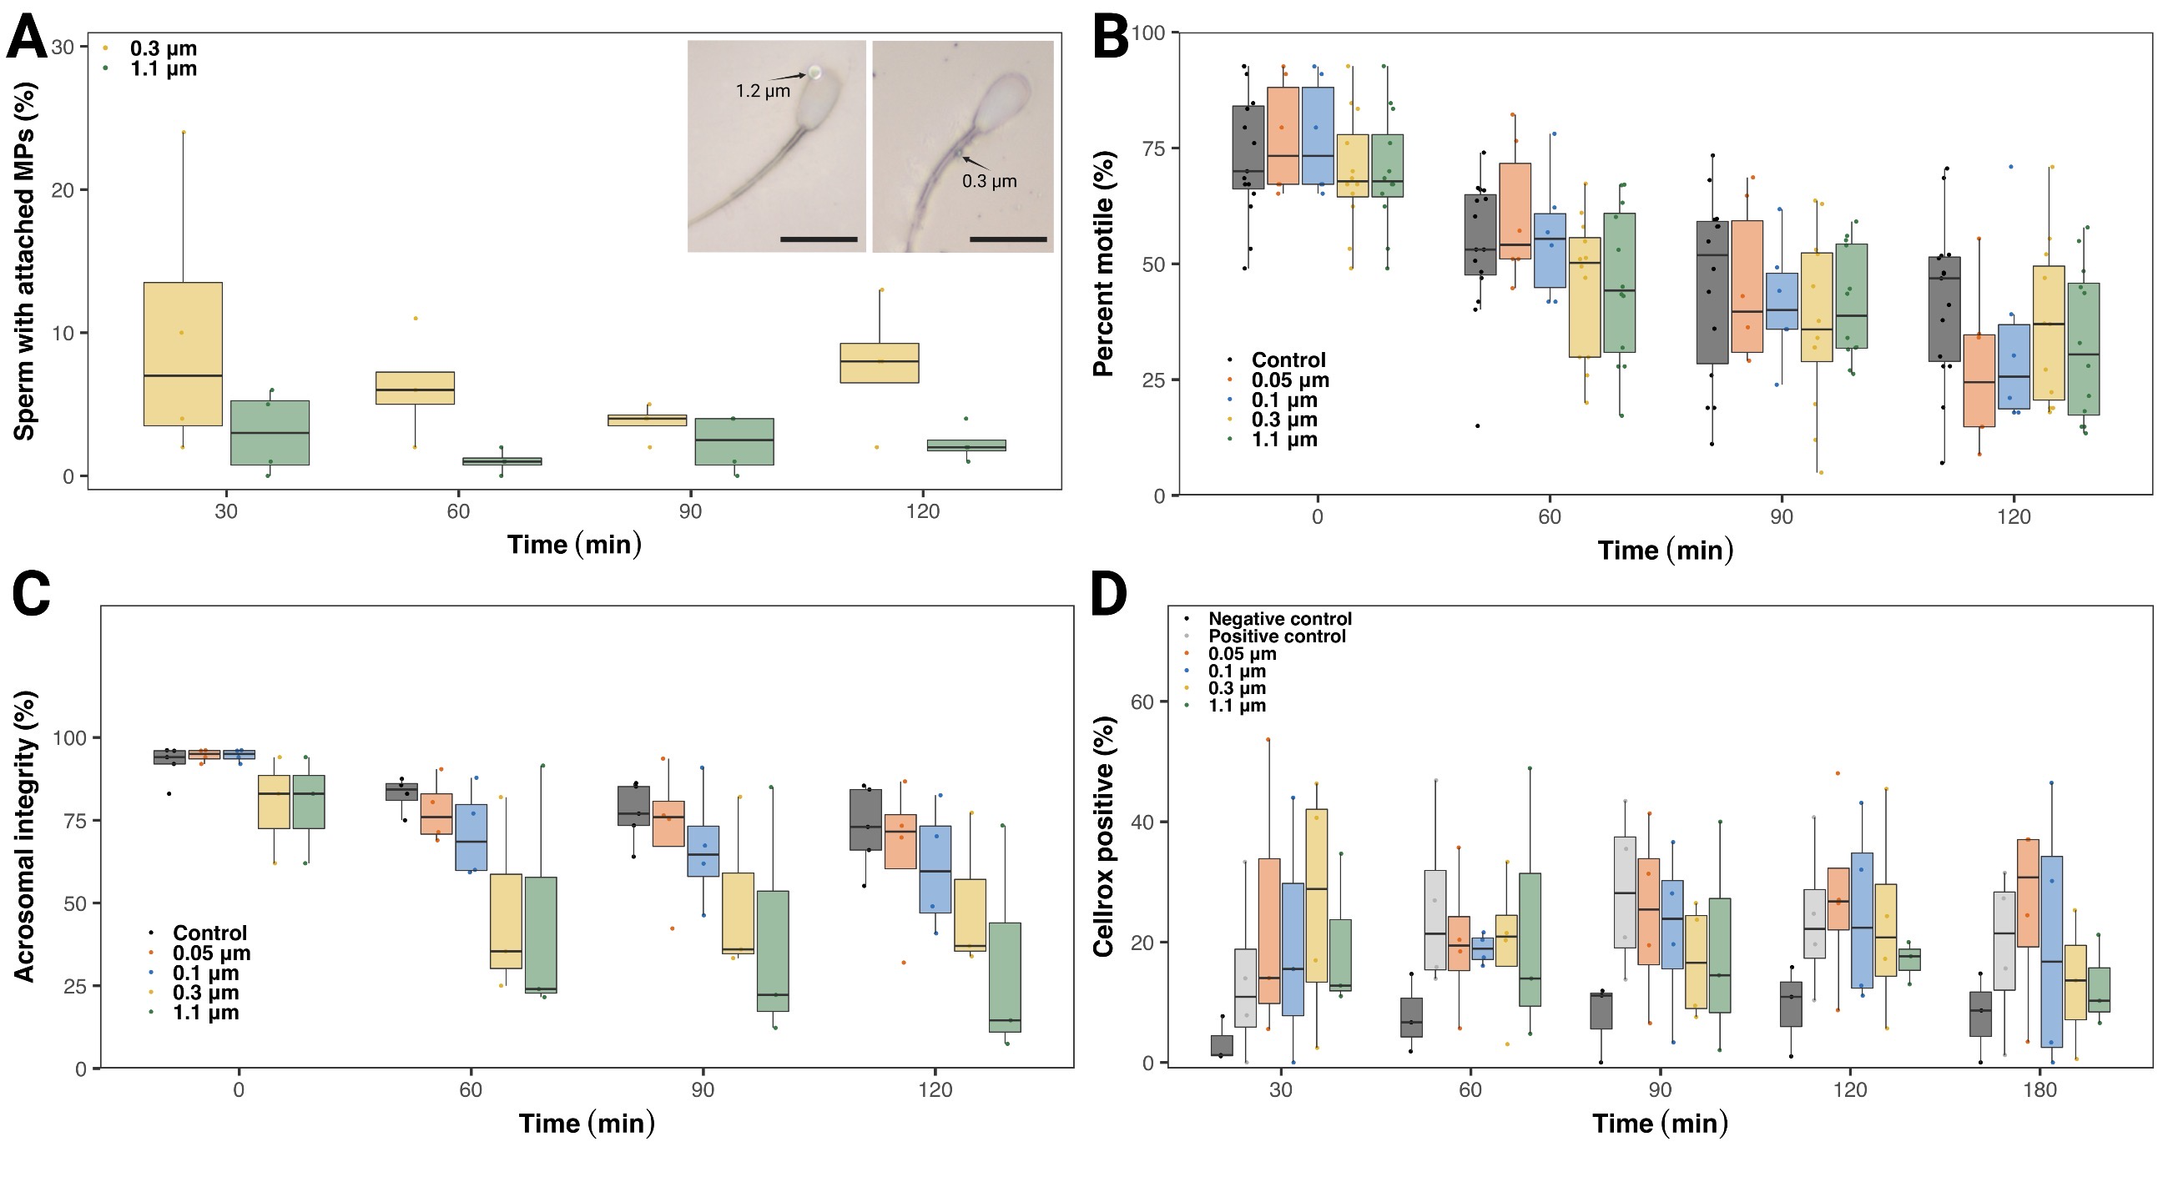

**Fig. 3.** **Polystyrene MP effects on sperm function *in vitro*.** (**A**) Percentage of sperm cells with polystyrene beads attached to their surface over time with picture examples of 0.3 and 1.1 μm attached beads. Attachment, did not change over time, and beads were not internalized by the spermatozoa, but the 0.3 μm beads attached more to the sperm surface than the 1.1 μm beads (p = 0.003). Scale bars in the insets have a length of10 μm. Boxplot depicting (**B**) the lack of any effect of polystyrene MPs of different sizes on sperm motility, (**C**) the significant reduction in acrosome integrity in all groups, independently of the size of the bead (p<0.001), and (**D**) the increase production in reactive oxygen species in all MPs groups when compared to the negative control, with 0.05 and 0.1 μm beads reaching levels similar to the positive control.

**MPs induce acrosome damage and oxidative stress but have no influence on sperm motility**

Sperm motility decreased over time (p < 0.001), but, irrespective of their size, the polystyrene beads did not induce significant changes in sperm motility when compared to the control group (Fig. 3B). Nonetheless, it was observed that the presence of MPs, independent of size, negatively impacted acrosome integrity when compared to the negative control (Fig. 3C, p < 0.001). Finally, we also observed that polystyrene beads significantly increased reactive oxygen species production at all time points compared to the negative control (Fig. 3D). The presence of the smaller 0.05 and 0.1 μm beads induced the production of reactive oxygen species to levels that were comparable to the positive control, which was stimulated with hydrogen peroxide, a known cellular reactive oxygen species inducer. The larger 0.3 and 1.1 μm beads also induced higher oxidative stress compared to the negative control (p = 0.02, and p = 0.036 respectively), although not to the same extent as the positive control, as was seen in sperm exposed to the 0.05 and 0.1 μm beads.

**Discussion**

This study provides the first comprehensive evaluation of the detrimental effects of MPs contamination on the mammalian reproductive system. Wforing From our *in vitro* analyses, we found that the concentrations of MPs that occurred in bovine follicular fluid were high enough to compromise the normal functioning of both male and female gametes. Collectively, these findings evidence as to how the billions of tons of MP pollution scattered across the planet may be contributing to the widespread increase in the rates of reproductive dysfunctions and gamete abnormalities, reductions in gamete production, and altered embryo development that have been increasing over recent decades (*15*–*23*).

**Abundance of MP particles in bovine follicular fluid**

Section describing the concentrations of MPs found in the bovine follicular fluid in relation to what other studies exist on mammals (and maybe in aquatic systems?). Talk about Type of particles encountered in FF and other plastic related particles… compare size and kind with other published data

has heretofore ed

**MP effects on oocyte maturation**

Section on the effects of MPs on oocytes, including the proteomics and potentially altered pathways.

**MP effects on sperm function**

Section on the effects of MPs on sperm function.

**Health implications**

Section on the broader health implications.

**Conclusions and future directions**

**Materials and Methods**

**MP contamination prevention**

To prevent sample contamination with airborne/materials MPs, all procedures were performed in a laminar flow hood, and all of the flasks and other apparatuses were replaced by glass materials whenever possible. Moreover, all materials and equipment used were rinsed three times with filtered (0.1 μm filter - brand) ultra-pure water prior to use. All reagents and water used in the protocols described below were filtered using a 0.1 μm filter before use.

**Microplastic polystyrene beads**

Polystyrene beads (SURF-CAL™ particle size standards) having sizes 0.047 μm, 0.100 μm, 0.304 μm and 1.112 μm were purchased from Thermo Fisher Scientific. The beads were obtained in deionized filtered water in a concentration of 3 x 108 particles mL-1 and were diluted according to the concentrations required for each experiment.

**Bovine oocyte and follicular fluid isolation**

Bovine ovaries were obtained from a local slaughterhouse and immediately transported to the laboratory at room temperature. Immature cumulus oocytes complexes (COCs) were aspirated from follicles with a size between 2 and 8 mm, together with follicular fluid, by using a vacuum pump and a 19G needle. Collected fluids with COCs from ~20-30 ovaries (N = 3 pools) were let to pellet for a maximum of 10 min. The pellet was then transferred to a petri dish with the equivalent amount of washing media (IVF Bioscience, UK) for oocyte selection, and remaining follicular fluid frozen at -20ºC for MPs isolation as described below.

**Microplastic isolation from follicular fluid**

Three pools of bovine follicular fluid left after removal of the COCs (20-30 ovaries) were used for microplastic isolation. Water controls from follicular fluid aspiration (N=2) were also processed using the same protocol. On day one, 2 mL of each sample were added to an Erlenmeyer for digestion in KOH 10% in a proportion of 1:25 (sample:digestion solution). The samples were incubated in a shaker at 60ºC and 250 rpm for 24 h. After this period, NaClO was added to each digestion to reach a final concentration of 7.5%, and samples were incubated for another 24 h in the shaker at 60ºC and 250 rpm. On day three, all samples were filtered in a 47 mm polytetrafluoroethylene polymer (PTFE) membrane (0.45 μm pores, Merck Millipore, USA) and rinsed with filtered ultra-pure water at least three times in order to prevent any NaClO and KOH contamination. Next, the membranes were placed in a beaker containing 50 mL of HNO3 20% and incubated in an ultrasonic bath (TI-H-5 MF2 230 V, Elma Schmidbauer GmbH, Germany) with 100% power, sweep function and a frequency of 45 kHz for 15 min, to transfer plastics/undigested matters from the membrane into the solution. The resulting solution was then kept in the shaker at 40ºC and 250 rpm for another 24 h. At the end of the third digestion day, the samples were filtered using 13 mm PTFE membranes (0.45 μm pores) and again rinsed three times with ultra-pure filtered water. The membranes were then mounted on a glass slide for microscopy and spectroscopy analysis.

**Oocyte isolation, incubation with MPs and nuclear stage analysis**

After collection as described above, the Petri dish was screened with a stereomicroscope and good quality oocytes (homogeneous cytoplasm and, at least, 3 layers of cumulus cells) were selected. COCs were then washed three times in washing media, and one time in BO-IVM (IVF Bioscience, UK), before being randomly assigned to one of three incubation groups: 1) a control group containing only maturation media (N = 114); 2) media containing PS beads of size 0.304 μm (N = 93); and 3) media containing PS beads of size 1.112 μm (N = 103). The concentration of the beads in each group was 1.2 million beads mL-1, or 0.0178 and 0.929 μg mL-1 for beads 0.3 and 1.1, respectively. The groups were cultured for 24 h in an incubator at 38.5ºC in a humidified atmosphere of 5% CO2 and 95% O2. After the 24 h period of incubation, the oocytes were denuded to remove cumulus cells, washed, and either fixed in paraformaldehyde 4% for nuclear staging or frozen at -80oC in pools of 9 oocytes for proteomics analysis (N = 5 pools per group).

For determining oocyte nuclear stage, fixed oocytes were washed in phosphate buffer saline (PBS), stained with Hoechst 33342 (5 μg mL-1) for 45 min and imaged in an EVOS M7000 Microscope using a ×40 NA 1.25 objective. The oocytes were analysed for nuclear stage (metaphase 1 or 2 – determined by the presence of an aligned metaphase plate with/without a polar body, respectively), degenerated (no visible nuclear material, or pyknotic nucleus), and broken zona pellucidae (visible breaks in the zona pellucida).

**Oocyte proteomics (Jan/Thomas)**

**Sperm incubation with MPs**

Frozen bull sperm were thawed at 37ºC for 30 s. The content of the straws were added to 3 mL of Tyrode’s medium supplemented with 2 mM sodium bicarbonate, 10 mM lactate, 1 mM pyruvate, 6 mg mL-1 fatty acid–free bovine serum albumin (BSA), 100 U mL-1 penicillin and 100 μg mL-1 streptomycin, centrifuged for 5 min at 700xg, and the pellet submitted to a standard swim-up separation using Tyrode’s medium supplemented with 25 mM sodium bicarbonate, 22 mM lactate, 1 mM pyruvate, 6 mg mL-1 fatty acid–free BSA, 100 U mL-1 penicillin and 100 μg mL-1 streptomycin (FERT) as overlaying medium. After 1 h, the supernatant was recovered, and sperm concentration was calculated using a Neubauer chamber. A total of 5x106 sperm mL-1 were used for incubation. For the incubation with microplastic, five treatment groups were prepared: 1) a control group of FERT media without beads; 2) FERT media containing 0.047 μm polystyrene beads; 3) FERT media containing 0.100 μm polystyrene beads; 4) FERT media containing 0.304 μm polystyrene beads; and 5) FERT media containing 1.112 μm polystyrene beads. The concentration of beads in all groups was 1.2 million beads mL-1 or 0.000083, 0.00066, 0.0178 and 0.929 μg mL-1 for beads 0.05, 0.1, 0.3 and 1.1, respectively. Sperm were incubated at 38.5ºC in a humidified atmosphere of 5% CO2 and 95% O2 for 2 h, and assessed for motility, acrosome integrity, and bead attachment analysis at 0, 1, 1.5 and 2 h.

**Sperm motility, bead attachment, and acrosome integrity assessment**

At each of the time points mentioned above, a 5 μL aliquot of sperm was either placed in a pre-warmed slide, covered with a coverslip and a video of at least 5 distinct areas for motility analysis was recorded, using an EVOS M7000 microscope; or added to a SuperFrost™ slide (Expredia), fixed with an equal volume of paraformaldehyde 4% and smeared across the slide. Those slides were left to dry at RT overnight before subsequent analysis of bead attachment and acrosome integrity. The sperm motility (N = 4 bulls) was calculated by analysing each video and counting total sperm, number of sperm moving, and number of sperm not moving. For the bead attachment, the confocal Raman microscope (WITec, Germany) was used, the slides were imaged using a ×100 DIC NA 0.9 objective, and random areas selected and analysed for the presence of sperm with microplastic attached to its surface. Each slide had at least 100 sperm cells counted (N = 4 bulls). Due to difficulties in visualizing the smallest 0.05 and 0.1 μm polystyrene beads, bead attachment was only quantified for the 0.3 and 1.1 μm beads.

For the acrosome integrity analysis (N=3 bulls), fixed slides were washed 3 times with PBS, and stained using a Hoechst 33342 (5 μg mL-1, Thermo Fisher Scientific, USA) and FITC-PNA Alexa 493 (5 μg mL-1, Thermo Fisher Scientific, USA) solution for 15 min. Slides were then washed another 3 times with PBS and mounted using an anti-fade solution (ProLong™ Gold Antifade Mountant, Thermo Fisher Scientific, USA) and a cover slip. The samples were imaged using a Leica Thunder DMi8 Microscope. The images were captured and processed using the Thunder software. The stained sperm cells were visualized with a ×20 NA 1.25 objective. At least 100 sperm cells/group were counted to determine percentage of cells with intact acrosome.

**Sperm oxidative stress analysis**

We were also interested in assessing the extent to which bovine spermatozoa experienced oxidative stress when exposed to MPs. To this end, for all of the 5 treatment groups described above, 2 μL mL-1 of CellRox™ Green Reagent (Thermo Fisher Scientific, USA) was added to the FERT media (N = 4 bulls). A positive control group was also created by adding 50 μM of H2O2 to stimulate sperm oxidative stress (*48*). Sperm were then incubated at 38.5ºC in a humidified atmosphere of 5% CO2 and 95% O2 for 3 h. Every 30 min, a 5 μL aliquot was taken and mounted in a RT slide and cover slip. Slides were allowed to cool down at room temperature for 1 min (to reduce sperm movement) and images were taken using an EVOS M7000 fluorescence microscope using ×20 NA 0.45. At least 100 sperm cells were counted, and midpiece CellRox™ stained sperm were considered positive.

**Confocal Raman spectroscopy of isolated microparticles and polystyrene beads**

A confocal Raman (alpha300 R, WITec, Germany) with a spectrometer (UHTS 300, WITec, Germany), and a 532 nm laser was used for the characterization of the microplastics. The microscope was operated by using the Control Five software, and the acquired data were processed by the Project Five software for compensation of background noise or cosmic radiation signal. Initially, the microscope was focused on the samples by using a ×50 NA 0.75 Zeiss objective, and the whole area of the membrane was imaged using the ‘Area Stitching’ option and the Z-stack auto-focus. Then, the Particle Scout software was used to identify all the particles present in the imaged membrane. The Raman spectra of each identified particle was then measured with a ×100 DIC NA 0.9 Zeiss objective, using an autofocus function, with a laser power of 10 mV, an accumulation of 4 and integration time of 0.45 s. The presence of microplastics was confirmed by matching the spectra found using the True Match- Integrated Raman Spectra Database Management software, with the S.T. Japan database (S.T. Japan Europe GmbH, Germany). Only matches with a value higher than 75% were considered for further analysis. Poly(tetrafluoroethylene-co-perfluoro-(alkyl vinyl ether)) – PTFE – and Perfluoroalkoxy alkane – PFA – particles were excluded from the analysis, since they are components of the pore membrane used for imaging.

All identified particles were classified as: 1) non-plastic related particles; 2) plastic polymers; 3) plasticizers ; 4) pigments; 5) coatings, solvents or fillers (CSF); and 6) unknown. Data S1 shows a list of all identified particles and their classification. Particle number was converted to weight by using the formula:

$$P_{w}= ρ×v$$

where Pw is particle weight, *ρ* is the particle density and *v* is the particle volume. See Table S1 for full information on the density of the particles analysed here.

To determine the potential source of the 0.3 μm and 1.1 μm polystyrene beads attached to sperm cells, the Raman spectra of identified polystyrene beads was measured with a ×100 DIC NA 0.9 Zeiss objective, with a laser power of 5 mV, an accumulation of 10 and integration time of 0.5 s. The polystyrene nature of the beads was confirmed by matching the spectra found using the True Match- Integrated Raman Spectra Database Management software, with the S.T. Japan database.

**Statistical analysis**

We were interested in studying the effects of MPs on sperm and oocyte function, as well as on oocyte proteomics. All of the functional data (i.e., sperm motility, sperm acrosomal integrity, sperm oxidative stress, sperm bead attachment, and oocyte maturation) consisted of percentages that ranged between 0 and 100. We therefore assessed the effects of MPs on these functional traits via generalised linear regression models with binomial error distributions. For the sperm oxidative stress, sperm bead attachment, and oocyte maturation, however, we used a quasibinomial error distribution to account for the fact that the data were under-dispersed. In additional, we also applied a hierarchical approach in which data from each bull and replicate were allowed to have randomly varying intercepts. The significance was checked using a Tukey HSD. Differences were considered significant when p < 0.05. All were carried out in(ver. ), and the scripts and packages used for carrying out our analyses are described in supplementary file SXXX as well as on the GitHub repository <https://github.com/NoonanM/MPs_and_Fertility>.

For the analysis of the proteomics data, NEED THE DETAILS FROM JAN/THOMAS. In addition, we used a random forest model to classify oocytes as belonging to either the control group, the 0.3 μm polystyrene bead treatment, or the 1.1 μm polystyrene bead treatment. The model was fit using the R package randomForest (Cutler and Wiener 2022), using 20,000 trees, sampled with replacement, and five candidate genes were sampled at each split. We then evaluated the classification accuracy of the model and assessed the relative importance of the individual genes in overall model performance.

References

1. M. Cole, P. Lindeque, C. Halsband, T. S. Galloway, Microplastics as contaminants in the marine environment: A review. *Mar. Pollut. Bull.* **62**, 2588–2597 (2011).

2. C. M. Rochman, T. Hoellein, The global odyssey of plastic pollution. *Science*. **368**, 1184–1185 (2020).

3. C. M. Free, O. P. Jensen, S. A. Mason, M. Eriksen, N. J. Williamson, B. Boldgiv, High-levels of microplastic pollution in a large, remote, mountain lake. *Mar. Pollut. Bull.* **85**, 156–163 (2014).

4. A. L. Lusher, V. Tirelli, I. O’Connor, R. Officer, Microplastics in Arctic polar waters: The first reported values of particles in surface and sub-surface samples. *Sci. Rep.* **5**, 1–9 (2015).

5. M. Bergmann, S. Mützel, S. Primpke, M. B. Tekman, J. Trachsel, G. Gerdts, White and wonderful? Microplastics prevail in snow from the Alps to the Arctic. *Sci. Adv.* **5**, 1–11 (2019).

6. European Commission, “A European Strategy for Plastics in a Circular Economy. Communication from the Commission to the European Parliament, the Council, the European Economic and Social Committee and the Committee of the Regions” (Brussels, 2018), (available at https://ec.europa.eu/environment/circular-economy/pdf/plastics-strategy.pdf).

7. M. C. Rillig, A. Lehmann, Microplastic in terrestrial ecosystems. *Science (80-. ).* **368**, 1430–1431 (2020).

8. R. K. Grosberg, G. J. Vermeij, P. C. Wainwright, Biodiversity in water and on land. *Curr. Biol.* **22**, R900–R903 (2012).

9. R. R. Hurley, L. Nizzetto, Fate and occurrence of micro(nano)plastics in soils: Knowledge gaps and possible risks. *Curr. Opin. Environ. Sci. Heal.* **1**, 6–11 (2018).

10. A. A. de Souza Machado, W. Kloas, C. Zarfl, S. Hempel, M. C. Rillig, Microplastics as an emerging threat to terrestrial ecosystems. *Glob. Chang. Biol.* **24**, 1405–1416 (2018).

11. S. Kaza, L. C. Yao, P. Bhada-Tata, F. Van Woerden, *What a Waste 2.0: A Global Snapshot of Solid Waste Management to 2050* (Washington, DC: World Bank, 2018; http://hdl.handle.net/10986/30317), vol. 1999.

12. S. L. Pimm, C. N. Jenkins, R. Abell, T. M. Brooks, J. L. Gittleman, L. N. Joppa, P. H. Raven, C. M. Roberts, J. O. Sexton, The biodiversity of species and their rates of extinction, distribution, and protection. *Science (80-. ).* **344** (2014), doi:10.1126/science.1246752.

13. G. Ceballos, P. R. Ehrlich, A. D. Barnosky, A. García, R. M. Pringle, T. M. Palmer, Accelerated modern human-induced species losses: Entering the sixth mass extinction. *Sci. Adv.* **1**, 9–13 (2015).

14. A. D. Barnosky, N. Matzke, S. Tomiya, G. O. U. Wogan, B. Swartz, T. B. Quental, C. Marshall, J. L. McGuire, E. L. Lindsey, K. C. Maguire, B. Mersey, E. A. Ferrer, Has the Earth’s sixth mass extinction already arrived? *Nature*. **471**, 51–57 (2011).

15. B.-I. Choi, A. J. Harvey, M. P. Green, Bisphenol A affects early bovine embryo development and metabolism that is negated by an oestrogen receptor inhibitor. *Sci. Rep.* **6**, 29318 (2016).

16. K. Sone, M. Hinago, A. Kitayama, J. Morokuma, N. Ueno, H. Watanabe, T. Iguchi, Effects of 17β-estradiol, nonylphenol, and bisphenol-A on developing Xenopus laevis embryos. *Gen. Comp. Endocrinol.* **138**, 228–236 (2004).

17. S. D’Angelo, R. Meccariello, Microplastics: A Threat for Male Fertility. *Int. J. Environ. Res. Public Health*. **18**, 2392 (2021).

18. F. Erdemir, D. Atilgan, F. Firat, F. Markoc, B. S. Parlaktas, E. Sogut, The effect of Sertraline, Paroxetine, Fluoxetine and Escitalopram on testicular tissue and oxidative stress parameters in rats. *Int. Braz J Urol*. **40**, 100–108 (2014).

19. L. Stuppia, M. Franzago, P. Ballerini, V. Gatta, I. Antonucci, Epigenetics and male reproduction: the consequences of paternal lifestyle on fertility, embryo development, and children lifetime health. *Clin. Epigenetics*. **7**, 120 (2015).

20. S. Rattan, C. Zhou, C. Chiang, S. Mahalingam, E. Brehm, J. A. Flaws, Exposure to endocrine disruptors during adulthood: consequences for female fertility. *J. Endocrinol.* **233**, R109–R129 (2017).

21. N. Kumar, S. Sharan, S. Srivastava, P. Roy, Assessment of estrogenic potential of diethyl phthalate in female reproductive system involving both genomic and non-genomic actions. *Reprod. Toxicol.* **49**, 12–26 (2014).

22. Y.-Y. Du, Y.-L. Fang, Y.-X. Wang, Q. Zeng, N. Guo, H. Zhao, Y.-F. Li, Follicular fluid and urinary concentrations of phthalate metabolites among infertile women and associations with in vitro fertilization parameters. *Reprod. Toxicol.* **61**, 142–50 (2016).

23. R. Sussarellu, M. Suquet, Y. Thomas, C. Lambert, C. Fabioux, M. E. J. Pernet, N. Le Goïc, V. Quillien, C. Mingant, Y. Epelboin, C. Corporeau, J. Guyomarch, J. Robbens, I. Paul-Pont, P. Soudant, A. Huvet, N. Le Goïc, V. Quillien, C. Mingant, Y. Epelboin, C. Corporeau, J. Guyomarch, J. Robbens, I. Paul-Pont, P. Soudant, A. Huvet, Oyster reproduction is affected by exposure to polystyrene microplastics. *Proc. Natl. Acad. Sci.* **113**, 2430–2435 (2016).

24. H. Jin, T. Ma, X. Sha, Z. Liu, Y. Zhou, X. Meng, Y. Chen, X. Han, J. Ding, Polystyrene microplastics induced male reproductive toxicity in mice. *J. Hazard. Mater.* **401**, 123430 (2021).

25. M. U. Ijaz, S. Shahzadi, A. Samad, N. Ehsan, H. Ahmed, A. Tahir, H. Rehman, H. Anwar, Dose-Dependent Effect of Polystyrene Microplastics on the Testicular Tissues of the Male Sprague Dawley Rats. *Dose-Response*. **19**, 1–11 (2021).

26. B. Hou, F. Wang, T. Liu, Z. Wang, Reproductive toxicity of polystyrene microplastics: In vivo experimental study on testicular toxicity in mice. *J. Hazard. Mater.* **405**, 124028 (2021).

27. F. Büks, M. Kaupenjohann, Global concentrations of microplastics in soils – a review. *SOIL*. **6**, 649–662 (2020).

28. S. Li, Q. Wang, H. Yu, L. Yang, Y. Sun, N. Xu, N. Wang, Z. Lei, J. Hou, Y. Jin, H. Zhang, L. Li, F. Xu, L. Zhang, Polystyrene microplastics induce blood–testis barrier disruption regulated by the MAPK-Nrf2 signaling pathway in rats. *Environ. Sci. Pollut. Res.* **28**, 47921–47931 (2021).

29. Y. Deng, Z. Yan, R. Shen, Y. Huang, H. Ren, Y. Zhang, Enhanced reproductive toxicities induced by phthalates contaminated microplastics in male mice (Mus musculus). *J. Hazard. Mater.* **406**, 124644 (2021).

30. R. An, X. Wang, L. Yang, J. Zhang, N. Wang, F. Xu, Y. Hou, H. Zhang, L. Zhang, Polystyrene microplastics cause granulosa cells apoptosis and fibrosis in ovary through oxidative stress in rats. *Toxicology*. **449**, 152665 (2021).

31. Z. Liu, Q. Zhuan, L. Zhang, L. Meng, X. Fu, Y. Hou, Polystyrene microplastics induced female reproductive toxicity in mice. *J. Hazard. Mater.* **424**, 127629 (2022).

32. J. C. Prata, I. F. Sequeira, S. S. Monteiro, A. L. P. Silva, J. P. da Costa, P. Dias-Pereira, A. J. S. Fernandes, F. M. da Costa, A. C. Duarte, T. Rocha-Santos, Preparation of biological samples for microplastic identification by Nile Red. *Sci. Total Environ.* **783**, 147065 (2021).

33. F. Collard, B. Gilbert, G. Eppe, E. Parmentier, K. Das, Detection of Anthropogenic Particles in Fish Stomachs: An Isolation Method Adapted to Identification by Raman Spectroscopy. *Arch. Environ. Contam. Toxicol.* **69**, 331–339 (2015).

34. T. Braun, L. Ehrlich, W. Henrich, S. Koeppel, I. Lomako, P. Schwabl, B. Liebmann, Detection of microplastic in human placenta and meconium in a clinical setting. *Pharmaceutics*. **13**, 1–12 (2021).

35. P. Pfohl, C. Roth, L. Meyer, U. Heinemeyer, T. Gruendling, C. Lang, N. Nestle, T. Hofmann, W. Wohlleben, S. Jessl, Microplastic extraction protocols can impact the polymer structure. *Microplastics and Nanoplastics*. **1**, 1–13 (2021).

36. Y. S. Ibrahim, S. Tuan Anuar, A. A. Azmi, W. M. A. Wan Mohd Khalik, S. Lehata, S. R. Hamzah, D. Ismail, Z. F. Ma, A. Dzulkarnaen, Z. Zakaria, N. Mustaffa, S. E. Tuan Sharif, Y. Y. Lee, Detection of microplastics in human colectomy specimens. *JGH Open*. **5**, 116–121 (2021).

37. P. Schwabl, S. Köppel, P. Königshofer, T. Bucsics, M. Trauner, T. Reiberger, B. Liebmann, Detection of Various Microplastics in Human Stool. *Ann. Intern. Med.* **171**, 453 (2019).

38. WHO, Infertility is a global public health issue. *World Heal. Organ.*, (available at https://www.who.int/reproductivehealth/topics/infertility/perspective/en/).

39. Infertility. *https://www.nhs.uk/conditions/infertility/* (2020).

40. H. Sun, T.-T. Gong, Y.-T. Jiang, S. Zhang, Y.-H. Zhao, Q.-J. Wu, Global, regional, and national prevalence and disability-adjusted life-years for infertility in 195 countries and territories, 1990–2017: results from a global burden of disease study, 2017. *Aging (Albany. NY).* **11**, 10952–10991 (2019).

41. K. L. Rooney, A. D. Domar, The relationship between stress and infertility. *Dialogues Clin. Neurosci.* **20**, 41–47 (2018).

42. A. D. Domar, P. C. Zuttermeister, R. Friedman, The psychological impact of infertility: a comparison with patients with other medical conditions. *J. Psychosom. Obstet. Gynaecol.* **14 Suppl**, 45–52 (1993).

43. S. Bechoua, S. Hamamah, E. Scalici, Male infertility: an obstacle to sexuality? *Andrology*. **4**, 395–403 (2016).

44. A. Starc, Infertility and Sexual Dysfunctions: A Systematic Literature Review. *Acta Clin. Croat.* (2019), doi:10.20471/acc.2019.58.03.15.

45. U. Mann, B. Shiff, P. Patel, Reasons for worldwide decline in male fertility. *Curr. Opin. Urol.* **30**, 296–301 (2020).

46. R. Canipari, L. De Santis, S. Cecconi, Female Fertility and Environmental Pollution. *Int. J. Environ. Res. Public Health*. **17**, 8802 (2020).

47. R. Sussarellu, M. Suquet, Y. Thomas, C. Lambert, C. Fabioux, M. E. J. Pernet, N. Le Goïc, V. Quillien, C. Mingant, Y. Epelboin, C. Corporeau, J. Guyomarch, J. Robbens, I. Paul-Pont, P. Soudant, A. Huvet, N. Le Goïc, V. Quillien, C. Mingant, Y. Epelboin, C. Corporeau, J. Guyomarch, J. Robbens, I. Paul-Pont, P. Soudant, A. Huvet, N. Le Goïc, V. Quillien, C. Mingant, Y. Epelboin, C. Corporeau, J. Guyomarch, J. Robbens, I. Paul-Pont, P. Soudant, A. Huvet, Oyster reproduction is affected by exposure to polystyrene microplastics. *Proc. Natl. Acad. Sci.* **113**, 2430–2435 (2016).

48. L. S. de Castro, P. M. de Assis, A. F. P. Siqueira, T. R. S. Hamilton, C. M. Mendes, J. D. A. Losano, M. Nichi, J. A. Visintin, M. E. O. A. Assumpção, Sperm Oxidative Stress Is Detrimental to Embryo Development: A Dose-Dependent Study Model and a New and More Sensitive Oxidative Status Evaluation. *Oxid. Med. Cell. Longev.* **2016**, 1–12 (2016).

**Acknowledgments**

**Funding:** This research was supported by LMUexcellent, funded by the Federal Ministry of Education and Research (BMBF) and the Free State of Bavaria under the Excellence Strategy of the Federal Government and the Länder. MAMMF was also supported by the Alexander von Humboldt Foundation in the framework of the Sofja Kovalevskaja Award endowed by the German Federal Ministry of Education and Research. MJN was supported by an NSERC Discovery Grant RGPIN-2021-02758.

**Author contributions:** Conceptualization: MAMMF; Methodology: MAMMF, NGR, TF, JS, MJN; Investigation: NGR, RF, RR, JS; Supervision: MAMMF, MJN, TF; Writing—original draft: NGR, MAMMF, MJN; Writing—review & editing: all authors.

**Competing interests:** Authors declare that they have no competing interests.

**Data and materials availability:** All data are available in the main text or the supplementary materials. Proteomics data was deposited on XXX, access via: ZZZ.

**Figures and Tables**

**~~Table 1.~~****~~Short title of the first table.~~** ~~Start table legends with a title (short description of the table). Format tables using the Word Table commands and structures. Do not use spaces, tabs or hard returns to create tables. Every vertical column should have a heading, followed by a unit of measure (if any) in parentheses. Units should not change within a column. Centered headings of the body of the table can be used to break the entries into groups. Footnotes should contain information relevant to specific cells of the table; use the following symbols in order, as needed:*, †, ‡, §, ||, ¶, #, **, ††, etc. (Don’t use footnotes in column heads; include any such details in sentence form after the table itself.)~~

**Supplementary Materials**

Data S1. Classification of all particles detected in follicular fluid and water samples.

Data S2. Summary of Raman spectroscopy data for all samples.

Table S1. Density values of identified MPs.

File SX. R code used to generate the results and figures presented in the main text.